US HISTORY II KEY IDEAS
Date:
Name:

*UNIT 21: THE UNITED STATES PURSUES IMPERIALISM

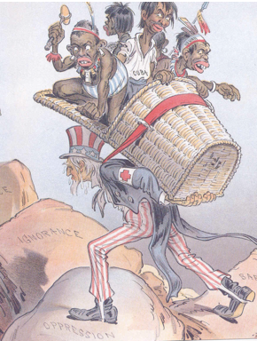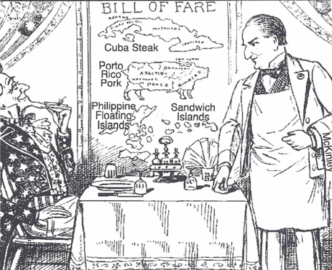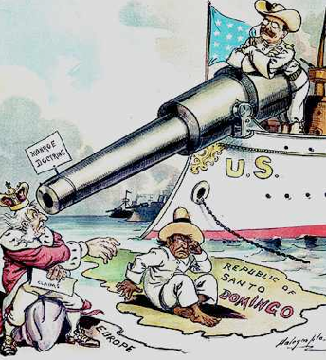

VOCAB DEFINITIONS

1. Imperialism / Acquisition - 6. Territories gained from the Spanish-American War

2. Commercial / Naval / Aggressive - 7. Why the Spanish-American War is a turning point

- Commodore / Annexed / Unbiased - 8. The Panama Canal / Why was it built? -

- US annexation of Hawaii (3 facts) - 9. Roosevelt’s “Big Stick” Policy -

5. New York World / New York Journal - 10. The Good Neighbor Policy -

IMPORTANT CONCEPTS

1. Describe 5 reasons why the US began to pursue a policy of imperialism in the 1890s:

2. Describe how Matthew Perry and the Open Door Policy increased US trade in Japan/China:

3. Describe 5 facts about Yellow Journalism. Why was it used? What news editors used it?

4. What led to the Spanish-American War in 1898? How was yellow journalism used before it?

5. Describe the Roosevelt Corollary to the Monroe Doctrine (1904). What policy was it like?
*UNIT 22: WORLD WAR I (1914-1918)

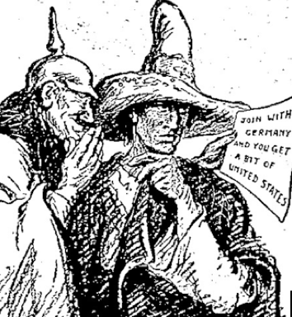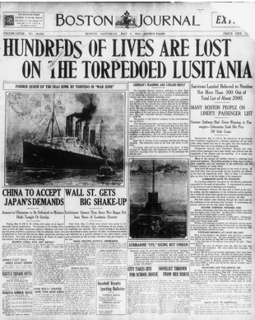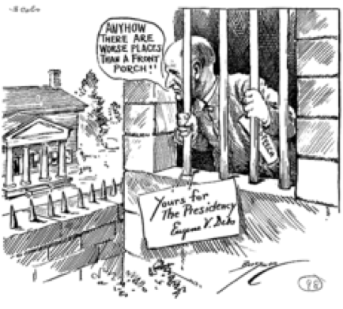

VOCAB DEFINITIONS

1. Neutrality (Isolationism) - 6. How the Atlantic Ocean affected WWI - -

2. Past examples of US isolationism (3) - 7. Espionage Act (1917) / Sedition Act (1918) -

- Sinking of the Lusitania (2 facts) - 8. Censor / Absolute / Habeas Corpus -

- Liberty Bonds - 9. The Washington Conference (1921) -

5. WWI effects on the economy (2) - 10. Kellogg-Briand Pact (1928) -

IMPORTANT CONCEPTS

1. How did President Wilson violate his policy of neutrality? How did Germany respond?

2. Describe the details of the Zimmerman Note. How did the American public react to it?

3. Describe the decision and argument of the Supreme Court decision Schenck v. U.S. (1919):

4. Describe 2 reasons why Woodrow Wilson’s Fourteen Points speech is significant in history:

- How did the US Congress follow a path of isolationism after WWI? Why did they do this?

*UNIT 23: THE “ROARING TWENTIES” (1920s)

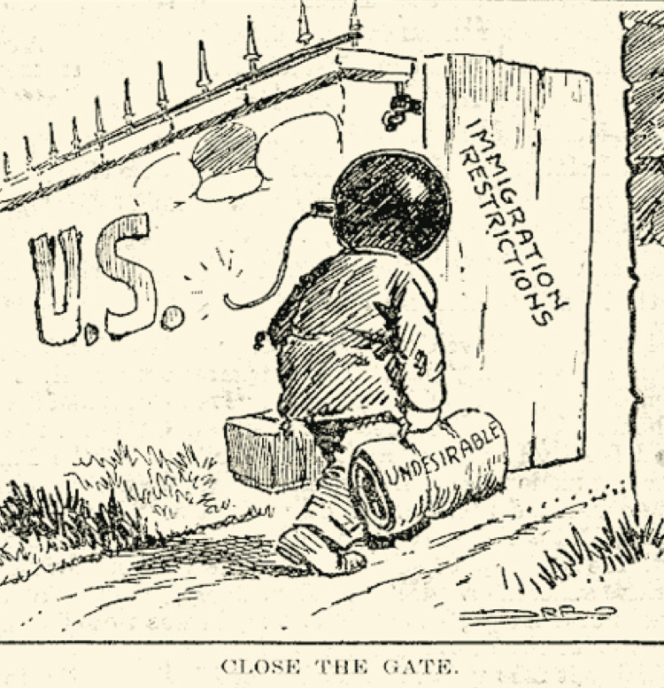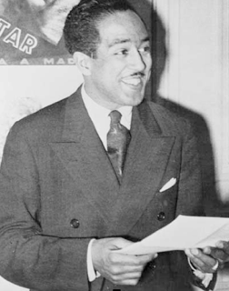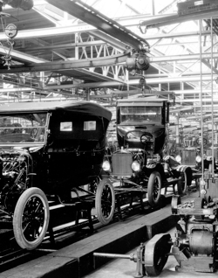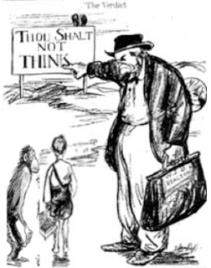

VOCAB DEFINITIONS

1. The Great Migration (3 facts) - 6. President Harding’s “Return to Normalcy” -

2. Sacco & Vanzetti Trial (3 facts) - 7. Subsidize / Consumer / Disillusionment -

- Rise of the KKK in the 1920s - 8. Authors of the 1920s (3) -

- National Origins Act (1924) - 9. What the authors were angry about (2) -

5. Definitive / Quota - 10. Failure of the 18th “Prohibition” amendment -

IMPORTANT CONCEPTS

1. Explain 3 facts about the Red Scare. Who led it? Why’d it occur? What were “Palmer Raids?”

2. Describe 5 facts about the 1920s economy under President Calvin Coolidge. Who suffered?

3. Describe the economic boom of the 1920s. Why’d it happen and what did Henry Ford do?

4. Describe 8 facts about the African-American-led Harlem Renaissance (People, ideas, values):

Authors/musicians (5) - Ideas/values (3) -

- Describe the Scopes Trial of 1925. What was the issue? What 2 ideas opposed each other?

The issue - Opposing ideas -
*UNIT 24: GREAT DEPRESSION, FDR & THE NEW DEAL (1930s)

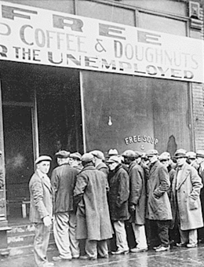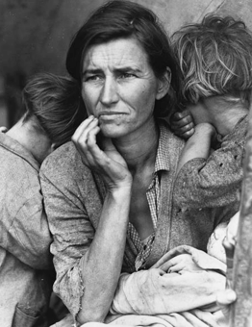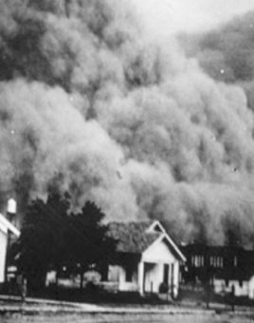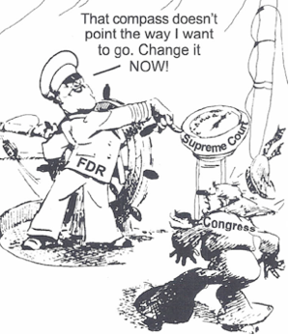

VOCAB DEFINITIONS

1. The Great Depression / “Black Tuesday” - 6. “The Okies” / The Grapes of Wrath (1939) -

2. Why President Herbert Hoover is blamed - 7. Franklin Roosevelt’s “New Deal” (3 goals) -

- “Trickle-down economics” - 8. How the New Deal changed US thinking -

- Wealth distribution in the US in 1929 - 9. FDR’s “court-packing scheme” -

5. “Hoovervilles” / The “Bonus Army” - 10. How the Supreme Court reacted to FDR -

IMPORTANT CONCEPTS

1. Describe 3 causes of the Great Depression. Also, list 3 warning signs that in the 1920s:

Causes (3) - Warning signs (3) -

2. Describe why the Great Plains region was called the Dust Bowl in the 1930s. What led to it?

3. Describe the four largest programs of FDR’s New Deal, the CCC, WPA, NRA and TVA:

4. Describe the Social Security Act, Labor Relations (Wagner) Act, & Fair Labor Standards Act:

- Describe 3 reasons that the Federal Deposit Insurance Corporation (FDIC) & Securities and Exchange Commission (SEC) were created:
*UNIT 25: WORLD WAR II (1939-1945)

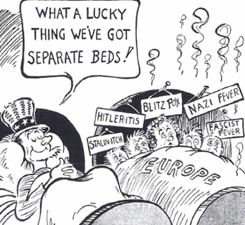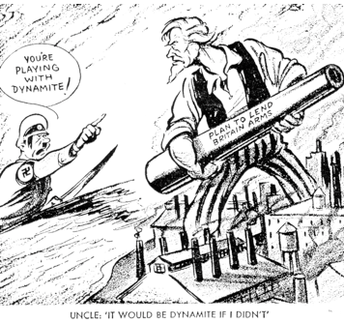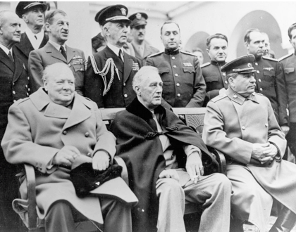

VOCAB DEFINITIONS

1. Disillusionment / Financiers - 6. “Arsenal for democracy” -

2. Neutrality Acts (1930s) - 7. FDR’s controversy / 22nd amendment (1951)

- Totalitarianism / Fascism / Militarism - 8. Pearl Harbor / Turning point of WWII -

- The Munich Conference (1938) - 9. How geography aided the USA -

5. Allied Powers / Axis Powers - 10. The Yalta Conference (3 facts) -

IMPORTANT CONCEPTS

1. Describe why the US returned to isolationism. What did a congressional investigation find?

2. What is appeasement and why’d it fail? What event marked the beginning of WWII in 1939?

3. Describe the Cash and Carry policy (1939) and Destroyers for Naval Bases Deal (1940):

Cash and Carry policy - Destroyers for Naval Bases Deal -

4. Describe the Lend-Lease Act. How did President Franklin Roosevelt defend this move?

Lend-Lease Act (1941) - FDR’s defense -

- How did the US end the Pacific war? What was this project called & what issue did it raise?

How the war ended - Project Name - Issue raised -
*UNIT 26: THE EFFECTS OF WORLD WAR II

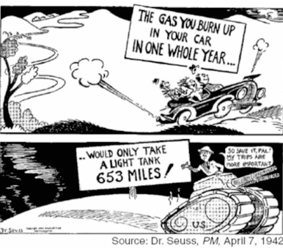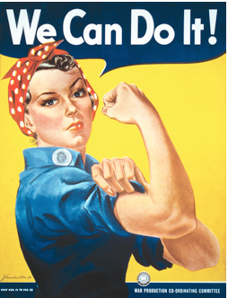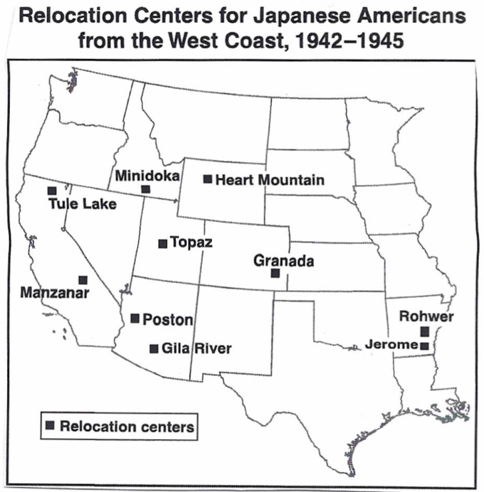

VOCAB DEFINITIONS

1. Genocide (Ethnic-Cleansing) - 6. President Truman’s Executive Order 9981 -

2. The Holocaust (“Final Solution”) - 7. Wartime Relocation Authority (WRA) -

- Atrocity / Civilian - 8. Japanese Internment Camps / Treason -

4. Wartime Rationing (3 facts) - 9. GI Bill (Servicemen’s Readjustment Act) -

5. The Tuskegee Airmen - 10. 3 ways the GI Bill helped military veterans -

IMPORTANT CONCEPTS

1. What were the Nuremberg Trials? What precedent did they set? What crime was charged?

Nuremberg Trials - Charged crime - Precedent -

2. Describe WWII’s effects on the economy. What effects did the increase in spending have?

Increase in spending - Effect on the Great Depression / Women -

3. Describe the experiences of African-Americans, both during and after WWII:

4. Describe the Supreme Court case Korematsu vs. United States (1944) (decision, effects, etc):

Court decision - 2 things it demonstrated -

5. Describe the “Baby Boom” (1946-1964). What led to it, how many were born, and the effect?

What led to it - How many babies born - Effect after WWII -
*UNIT 27: THE BIRTH OF THE COLD WAR & MCCARTHYISM

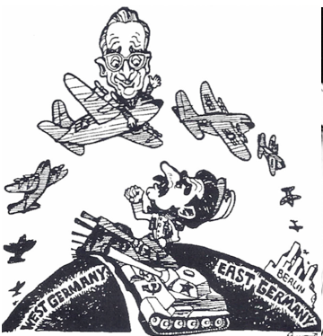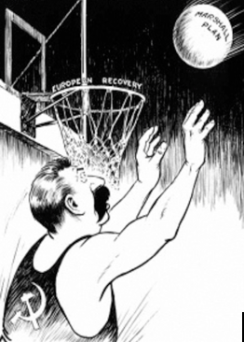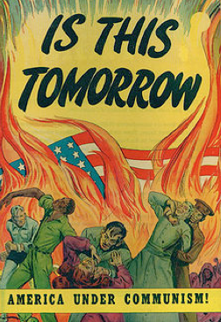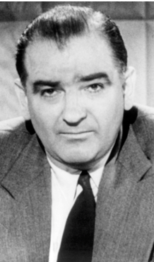

VOCAB DEFINITIONS

1. United Nations (1945) / Collective security - 6. “Mutual defense” -

2. Universal Declaration of Human Rights (1948) - 7. 2 reasons the US got involved in Asia -

- “The Superpowers” / “Satellite states” - 8. The Korean War / 38th Parallel -

- How Greece & Turkey were aided - 9. House Un-American Activities Committee -

5. The Truman Doctrine (1947) - 10. The Rosenberg trial / Alger Hiss -

IMPORTANT CONCEPTS

1. How did the USA & USSR have different ideologies (beliefs) after WWII? What did this raise?

US ideologies (3) - USSR ideologies (3) - What this raised -

2. Describe 2 facts each about the US Cold War policies of containment and the Marshall Plan:

Containment (2 facts) - The Marshall Plan (2 facts) -

3. How was Germany divided in 2 ways after WWII? What happened during the Berlin Airlift?

4. What were NATO and the Warsaw Pact? Why were they formed and who was in each?

NATO (3 facts) - Warsaw Pact (3 facts) -

- Describe what Senator Joseph McCarthy did. What does “McCarthyism” symbolize?

Sen. Joseph McCarthy - McCarthyism -
*UNIT 28: THE 1950s & THE EARLY CIVIL RIGHTS MOVEMENT

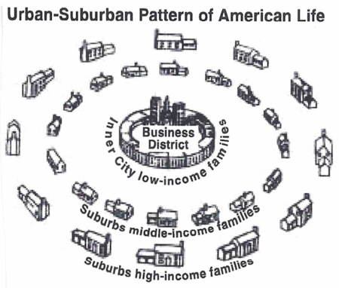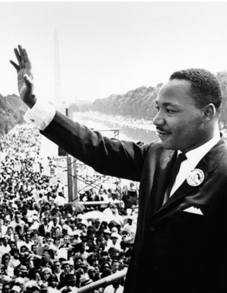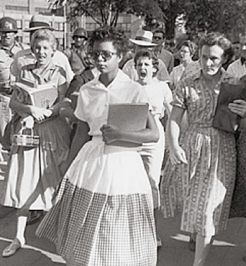

VOCAB DEFINITIONS

1. Dwight Eisenhower / “Arms Race” - 6. Civil Rights Movement / Jackie Robinson

2. Sputnik / “Space Race” - 7. Martin Luther King Jr. / Rosa Parks -

- The Cuban Revolution / Guatemala - 8. Chief Justice Earl Warren (1953-1969) -

- US intervention in Latin America (3 examples) - 9. How Plessy v. Ferguson was reversed -

5. Suburbs / Interstate Highway Act (1956) - 10. Filibuster -

IMPORTANT CONCEPTS

1. Describe President Eisenhower’s “domino theory” and his “Eisenhower Doctrine.”

The “Domino Theory” - “Eisenhower Doctrine” -

2. Describe the economic prosperity of the 1950s. How did the GI Bill help?

Economic prosperity (2 facts) - GI Bill -

3. Describe the baby boom and the growth of suburban areas during the 1950s.

Baby Boom (3 facts) - Growth of suburbs (3 facts) -

4. Describe the Supreme Court case Brown v. Board of Education (1954) (issue, decision, effect)

5. How did the South react to desegregation? What happened at Little Rock, Arkansas in 1957?

*UNIT 29: THE 1960s - A TIME OF SOCIETAL CHANGE

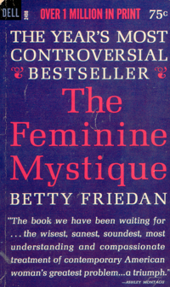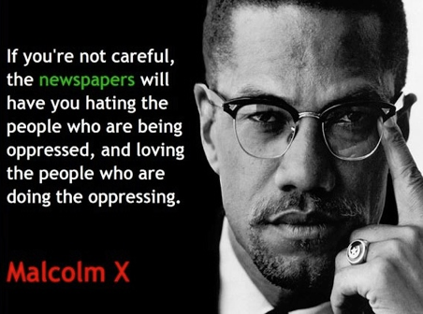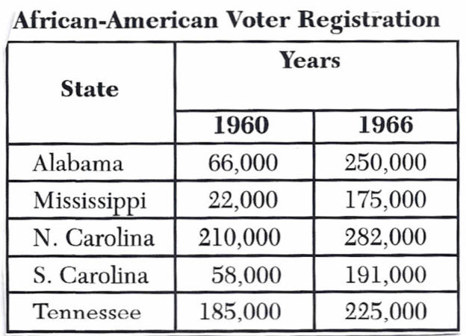

VOCAB DEFINITIONS

1. Greensboro, North Carolina (1960) - 6. Black power / Black separatism -

2. Freedom Rides / Medgar Evers - 7. Betty Friedan / Feminine Mystique (1963) -

- Birmingham, Alabama (1963) - 8. Rachel Carson / Silent Spring (1962) -

- March on Washington (1963) - 9. Ralph Nader / Unsafe at Any Speed (1965)

5. The 24th amendment (1964) - 10. Americans with Disabilities Act (1990) -

IMPORTANT CONCEPTS

1. Describe the Civil Rights Act (1964) and Voting Rights Act (1964). Why are they significant?

Civil Rights Act (1964) - Voting Rights Act (1964) -

2. Describe what Huey Newton and Malcolm X did. What happened after Malcolm X’s murder?

Huey Newton (1942-1989) - Malcolm X (1925-1965) -

3. Describe the following: the Equal Pay Act (1972), Title IX, and Equal Rights Amendment:

4. Describe the Supreme Court case Roe v. Wade (1973) and what affirmative action laws were:

Roe v. Wade (1973) - Affirmative action laws -

5. Describe the United Farm Workers (UFW) and 3 things that Cesar Chavez fought for:

United Farm Workers - Cesar Chavez -
*UNIT 30: TENSIONS WITH CUBA & THE GREAT SOCIETY

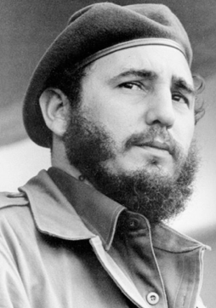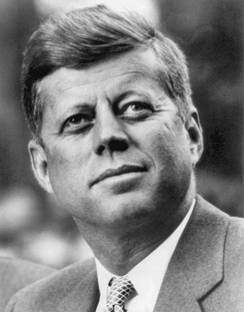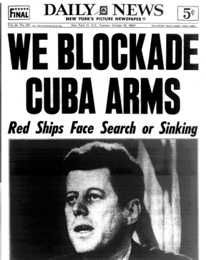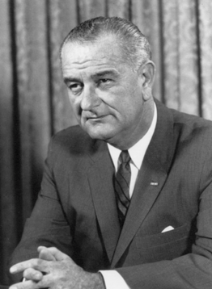

VOCAB DEFINITIONS

1. Why Cold War tensions increased in 1956 - 6. Reason for the USA’s embargo on Cuba -

2. Fulgencio Batista / Fidel Castro - 7. Alliance for Progress (2 facts) -

- Why Castro asked the USSR for arms - 8. Neil Armstrong / The Peace Corps -

- Cuban Missile Crisis (Oct, 1962) - 9. JFK’s assassination (11/22/63) -

5. Nuclear Test Ban Treaty (1963) - 10. Voting Rights Act / Food Stamp Act -

IMPORTANT CONCEPTS

- Describe what happened during the Cuban Revolution. What was the Bay of Pigs invasion?

Cuban Revolution (1959) – Bay of Pigs invasion (1961) -

2. How did JFK respond to the Cuban Missile Crisis? How did both superpowers compromise?

3. Describe Lyndon B. Johnson’s Great Society program. What was the Medicare/Medicaid Act

Great Society (2 facts) - Medicare/Medicaid Act (1965) -

4. Describe the three programs created by the Economic Opportunity Act (1964):

Job Corps - Project Head Start - Project Upward Bound -

5. List 4 previous laws, programs and/or amendments that LBJ’s Great Society was similar to:

*UNIT 31: THE VIETNAM WAR (1955 – 1975)

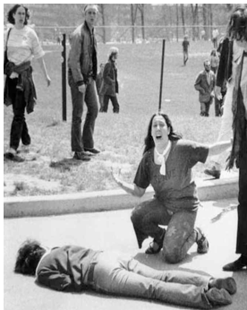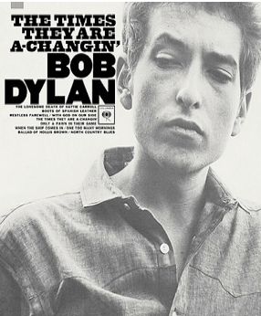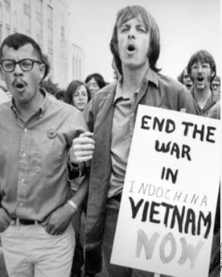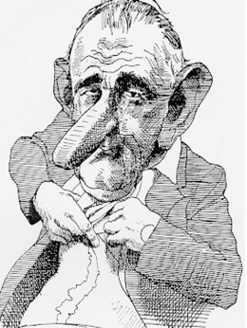

VOCAB DEFINITIONS

1. First Indochina War (1946-1954) - 6. Viet Cong / Viet Minh -

2. Why the USA got involved - 7. Students for a Democratic Society (SDS) -

- Ho Chi Minh / Ngô Đình Diệm - 8. “Draft dodgers” / Kent State shooting -

- How JFK escalated the Vietnam War - 9. “Hippies” (3 facts) / Bob Dylan -

5. How LBJ escalated the Vietnam War - 10. Election of Nixon / How the war ended -

IMPORTANT CONCEPTS

1. How did the domino theory lead to the Vietnam War? What world events worried JFK?

The “Domino Theory” - Events that worried JFK -

2. Explain the Gulf of Tonkin incident (8/4/64) and the Gulf of Tonkin Resolution after it:

Gulf of Tonkin incident - Gulf of Tonkin Resolution -

3. Describe 5 reasons why the USA lost the Vietnam War. How did leader Ngô Đình Diệm act?

4. Describe why the public grew angry. What did colleges do? How did LBJ react in 1968?

Reasons for the public anger - LBJ’s reaction -

5. Describe 5 facts about the War Powers Act (1973). How did it alter balances of power?

War Powers Act (1973) - Balance of power -
*UNIT 32: THE NIXON ADMINISTRATION (1969 – 1974)

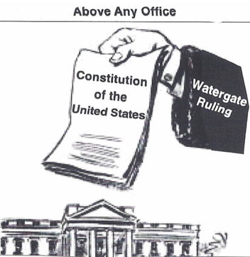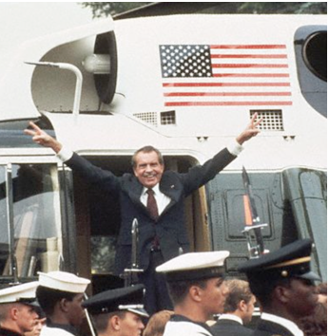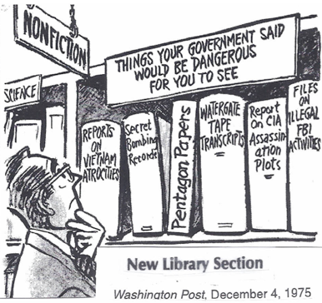

VOCAB DEFINITIONS

1. Election of 1968 (2 facts) - 6. The Environmental Protection Agency (EPA)

2. Liberalism / Conservatism - 7. The 26th amendment (1971) -

- Nixon’s 1972 visit to China (2 facts) - 8. Consumer Rights Movement (3 facts) -

- 2 effects of Nixon’s China visit - 9. All the President’s Men (1974) -

5. Strategic Arms Limitation Treaty (SALT) - 10. Effect of Watergate on the American public

IMPORTANT CONCEPTS

1. Describe the Cold War period known as détente (1969-1979). What did both nations fear?

2. Describe 3 ways Nixon was both conservative and liberal during his presidency:

Nixon’s conservative side (3) - Nixon’s liberal side (3) -

3. Describe 5 facts about the Watergate affair. How was the White House linked to the crime?

4. Describe 3 effects of the Supreme Court case United States v. Richard Nixon (1974):

- What did Nixon do on 8/9/74? Why’d he do this? What did new president Gerald Ford do?

What Nixon did - Why - What Ford did -
*UNIT 33: PRESIDENTS CARTER, REAGAN, BUSH & CLINTON

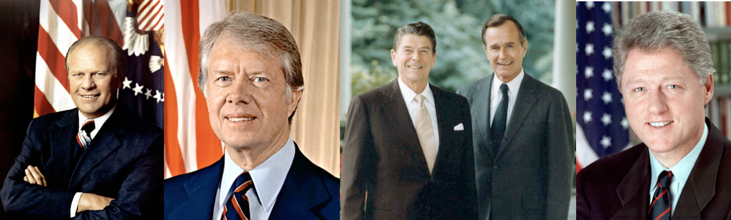

VOCAB DEFINITIONS

1. Gerald Ford’s term (2 facts) - 6. Effect of the Iran-Contra Affair on the public -

2. 1973 OPEC oil embargo (3 effects) - 7. “Chief Executive” / “Chief Diplomat” -

- Recession / “Stagflation” / Mediate - 8. Nations that Clinton sent US troops to (4) -

- Jimmy Carter’s foreign policy problem - 9. Reasons the US got involved globally (2) -

5. Federal debt / US distribution of wealth - 10. What Clinton’s impeachment showed -

IMPORTANT CONCEPTS

1. Describe the following 3 ways that Jimmy Carter’s presidency increased human rights:

Draft dodgers - Apartheid - Camp David Accords (3 facts) -

2. Describe 5 facts about President Reagan’s idea of supply-side economics. How did it fail?

Supply-side economics (5 facts) -

3. Describe President Reagan’s greatest triumph and most controversial failure:

End of the Cold War - Iran-Contra Affair (1986) -

4. Describe the Persian Gulf War (1991). How are the Korean and Vietnam Wars similar?

Why Bush sent troops - How Korean/Vietnam Wars are similar -

- Describe two ways President William Clinton was similar to President Andrew Johnson:

*UNIT 34: MODERN ECONOMIC ISSUES

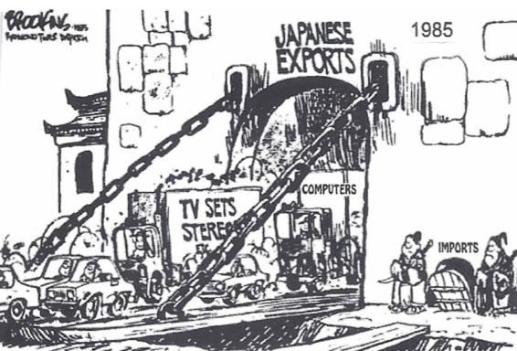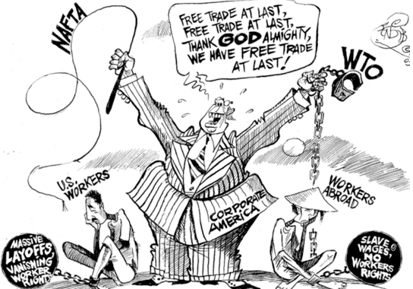

VOCAB DEFINITIONS

1. Problems for American farmers (2) - 6. Imports/ Exports / Tariff / Quota -

2. Reasons for the loss of manufacturing jobs - 7. Why financial interdependence is risky -

- Automation / “Service industries” - 8. Outsourcing / Effect of outsourcing -

- Federal debt increase from 1970-1998 - 9. US problems with oil (3 facts) -

5. Reasons for the debt increase (3) - 10. Standard Oil, AT&T, Microsoft (similarity) -

IMPORTANT CONCEPTS

1. What is a trade imbalance, a.k.a. deficit? What nations have the US had trade deficits with?

Trade imbalance (deficit) - Nations the US has had trade deficits with -

- Describe 5 economic goals and policies of the Republican Party since the 1980s:

3. What do globalization and interdependence mean? What has made these processes faster?

Globalization - Interdependence - Computers -

4. What do NAFTA, WTO, GATT, and EU stand for? Why did President Clinton support them?

5. Describe 5 facts about the 2008 Global Financial Crisis. What negative effects has it had?
*UNIT 35: A CHANGING POPULATION: THE USA OF THE FUTURE

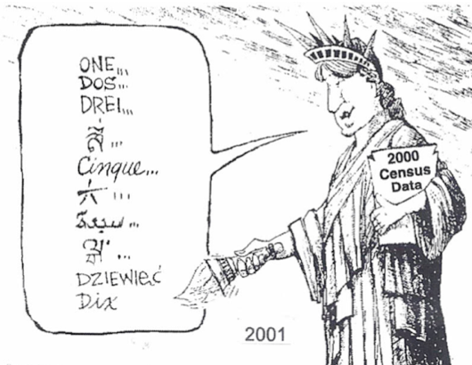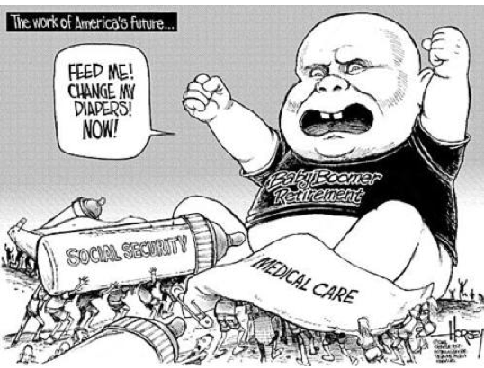

VOCAB DEFINITIONS

1. 3 Reasons for a census / Reapportion - 6. 21st century / “Living wage” -

2. “The graying of America” - 7. Social mobility -

- Prediction about the US population by 2020 - 8. Ethnic diversity -

- Top 5 most populous states (2000 census) - 9. Illegal immigration -

5. 3 reasons that large-population states are powerful - 10. US immigration policies -

IMPORTANT CONCEPTS

- Describe 5 reasons why the USA has seen a huge increase in senior citizens since 1900:

2. Describe why Social Security and Medicare/Medicaid may end. What is a possible solution?

Why Social Security/Medicare/Medicaid may end - Possible solution -

3. Describe 3 changing attitudes in the US towards families that were reflected in the census:
4. The early 21st century (2000s) has seen lots of economic instability in the USA. Explain:

Causes of instability (3) - Effects of instability (3) -

- Where are new immigrants to the US since the 1980s coming from? Why are they coming?

*UNIT 36: THE 2000 ELECTION & GEORGE W. BUSH (2001-2009)

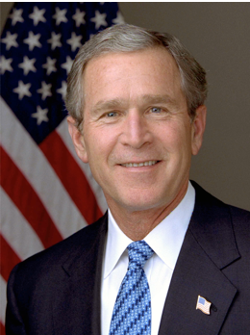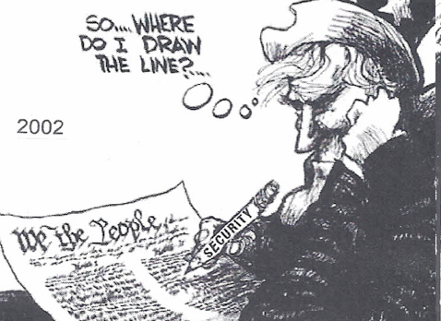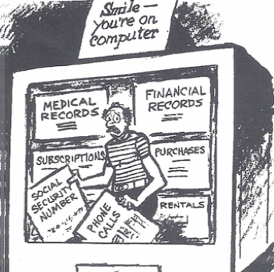

VOCAB DEFINITIONS

1. Bush v. Gore (2000) - 6. Sept. 11th, 2001 attacks (3 facts) -

2. Examples of controversial elections (4) - 7. 3 Similar laws/cases to the Patriot Act -

- Compromise of 1877 - 8. “War on Terror” / Invasion of Afghanistan -

- Effect of the 1876 election on the South - 9. “Operation Iraqi Freedom” -

5. Examples of swing states (10) - 10. Department of Homeland Security (3 facts)

IMPORTANT CONCEPTS

1. Describe why the 2000 election was controversial. How was it settled? What state was key?

Why it was controversial - How it was settled - State -

2. Why was the election of 1876 between Tilden and Hayes controversial? How was it settled?

Why it was controversial - How it was settled -

3. Describe why swing states are important. Why do some want the electoral college abolished?

“Swing state” – Electoral college argument -

4. Describe the Patriot Act (2002). Why was it passed? Why is it controversial and criticized?

Patriot Act (2002) - 3 reasons it’s controversial -

5. Describe the Iraq War (2003-2011). Why did US forces invade? What are 3 effects of the war?

UNIT 37: MODERN SUPREME COURT CASES & THE 21ST CENTURY

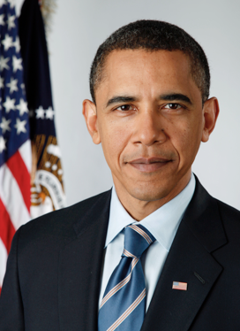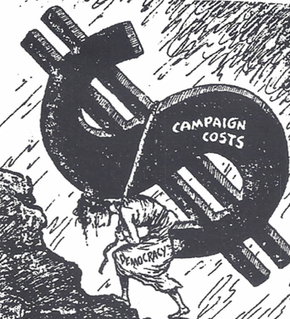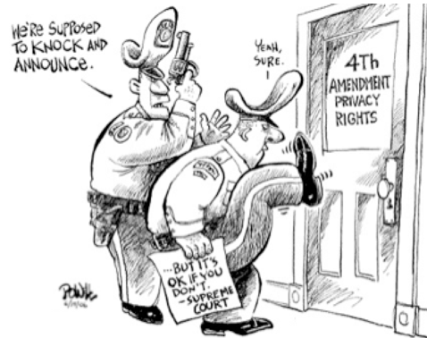

VOCAB DEFINITIONS

1. Mapp v. Ohio (1961) - 6. Engel v. Vitale (1962) -

2. Gideon v. Wainwright (1963) - 7. Tinker v. Des Moines School District (1969) -

- Miranda v. Arizona (1966) - 8. New Jersey v. T.L.O. (1985) -

- New York Times Co. vs. U.S. (1971) - 9. Vernonia School District v. Acton (1995) -

5. Planned Parenthood v. Casey (1992) - 10. Citizens United v. Federal Election Commission

IMPORTANT CONCEPTS

1. How are the Mapp, Gideon, & Miranda cases similar? What does “due process of law” mean?

How Mapp, Gideon, Miranda cases are similar - “Due process of law” -

2. What were the Pentagon Papers? What case in history is New York Times vs. U.S. similar to?

Pentagon Papers - Similar case -

3. What natural disasters provided possible evidence of global warming? What things cause it?

Natural disasters (2) - Causes of global warming (2) -

4. What are PAC’s? Why have they gotten more dangerous and powerful since 2010?

Political Action Committees (“PAC’s”) -

- What was the Affordable Care Act (2010)? Why was it an important moment in US history?

